Installation of Git, Java, Eclipse IDE, Spring Boot STS, Databases, VS Code, Node.js, Postman

Postman App
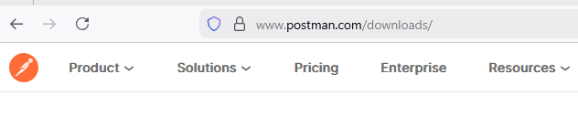
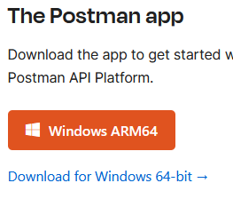
Click on the “Download for windows 64 bit”
Run the exe file after download.
Signin with google/github account.
---------------------------------------------------------------------

(You might be already installed last semester)

1) Installation of Git
Steps:
- Go to the official Git website → https://git-scm.com
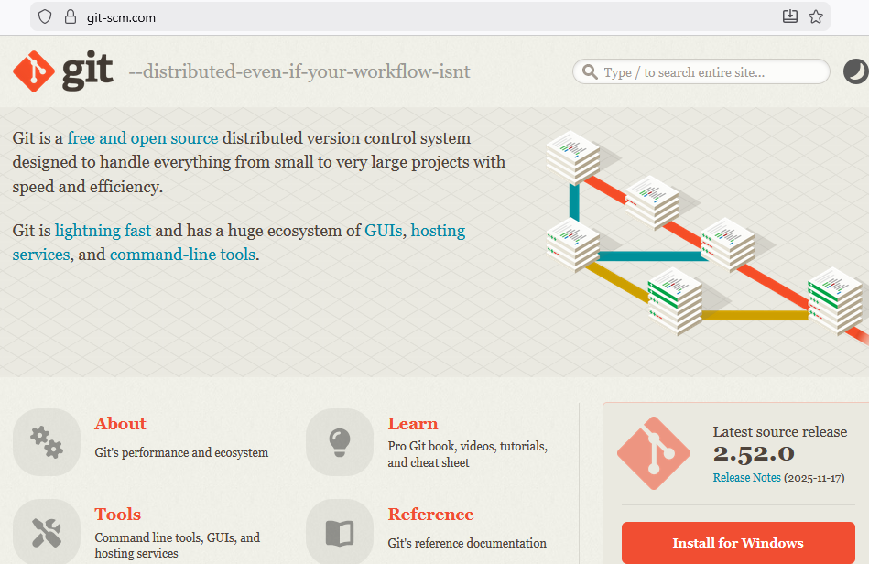
Click on Intall for Windows Button
• Open the downloaded .exe file
• Click Next until finish (keep default options)
• After installation, open Command Prompt and check: git - - version
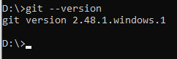

2) Installation of Java (JDK)
Steps:
- Go to → https://www.oracle.com/java/technologies/downloads/
(or use OpenJDK: https://adoptium.net/ )
• Download JDK 17 (LTS) or JDK 21 (LTS)
• Run the installer and complete the setup
• Set JAVA_HOME:
- Search Environment Variables
- 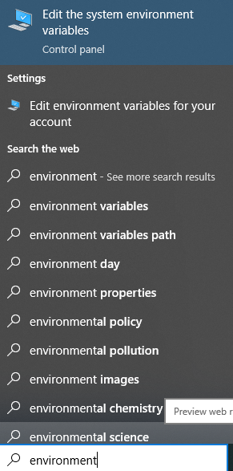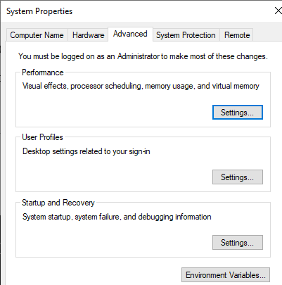
Click on “Environment Variable”
- Click on the “New” Button in the System Variable section, and variable name and path as follows:
Name: JAVA_HOME
Value: C:\Program Files\Java\jdk-17

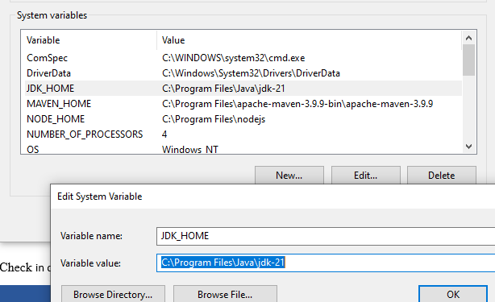
Check in command prompt: java –version
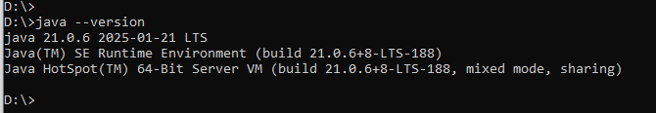

3) Installation of Eclipse IDE
Steps:
- Go to → https://www.eclipse.org/downloads/
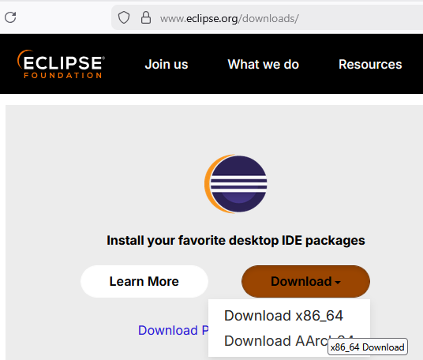
Click on Download x86_64
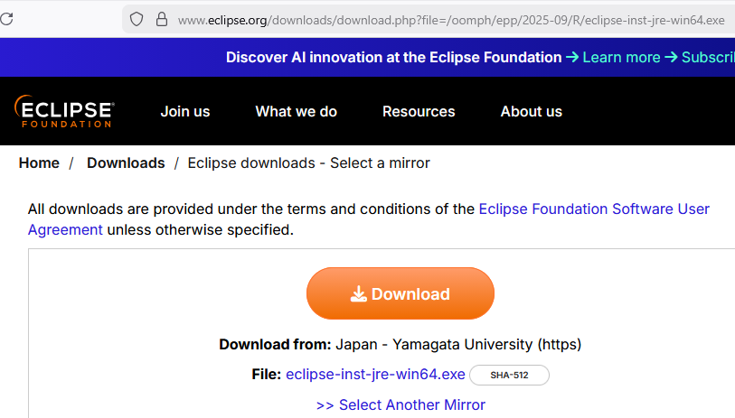
Click on Download Button. It will download latest version exe file.
Run the exe file. (Double click on the downloaded exe file)
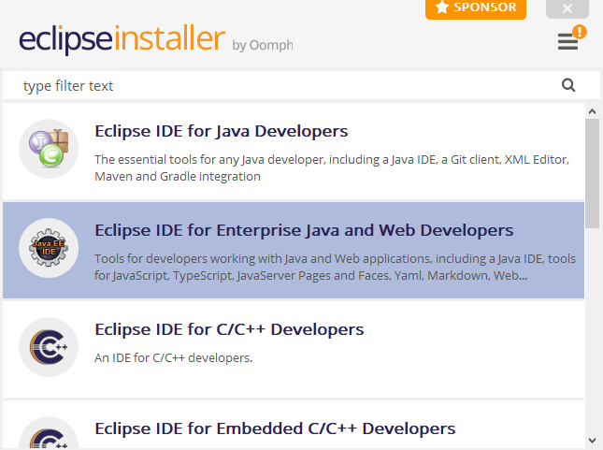
• Select the “Eclipse IDE for Enterprise Java and Web Developers” option
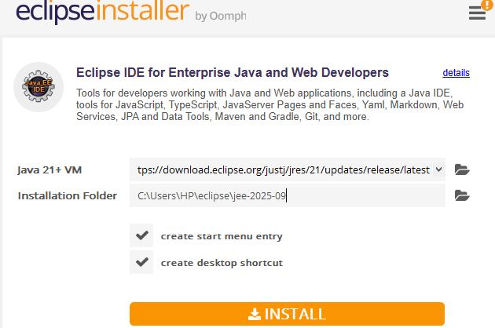
Click on the INSTALL button
• Choose workspace location (Where you want to store all you eclipse projects, specify its path, or keep it default one) →
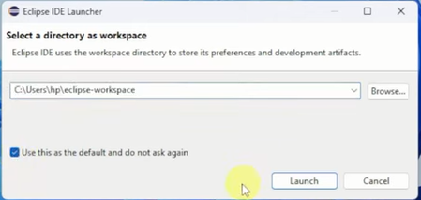
Click Launch

4) Installation of Spring Boot STS (Spring Tool Suite)
Steps:
- Go to → https://spring.io/tools
• Download STS for Windows
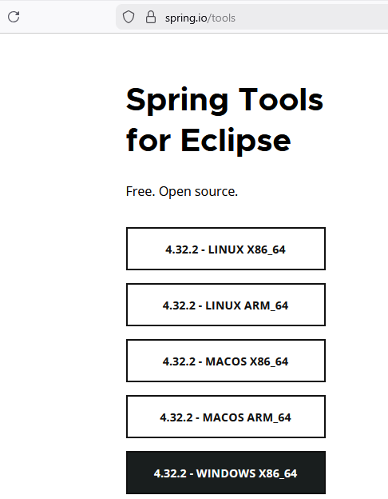
• Extract the ZIP
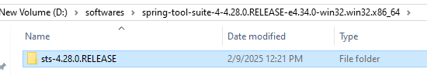
• Run SpringToolSuite4.exe
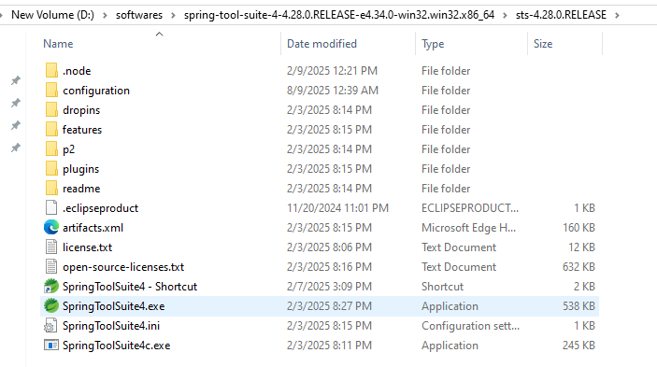
Create a shortcut for this exe file, and place it on the desktop, to open easily.
Right click on the exe file and choose “create shortcut” option
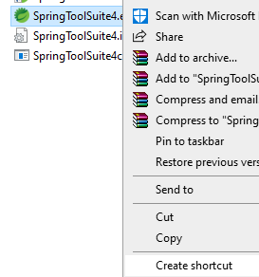

5) Database Installation (MySQL)
Steps:
- Go to → https://dev.mysql.com/downloads/installer/
- Download MySQL Installer (Community)
- Select:
  - MySQL Server
  - MySQL Workbench
- Click Install
- Set root password
- Finish setup
- 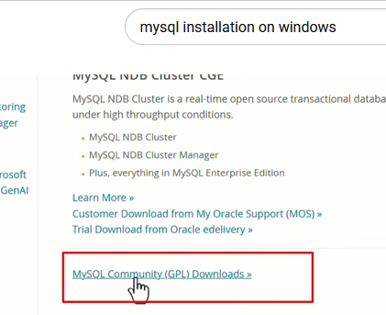
- 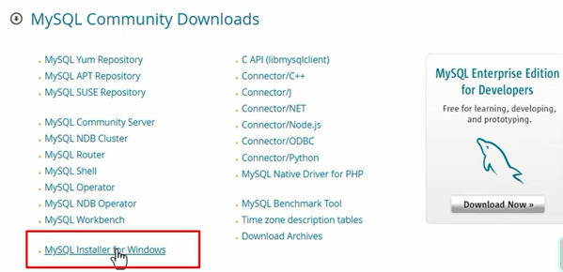
- 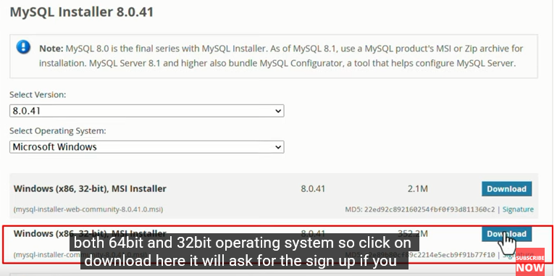

- 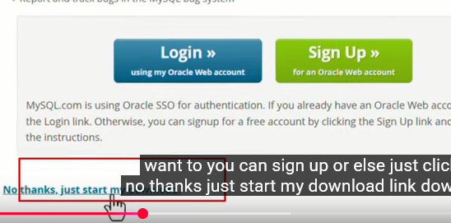

- 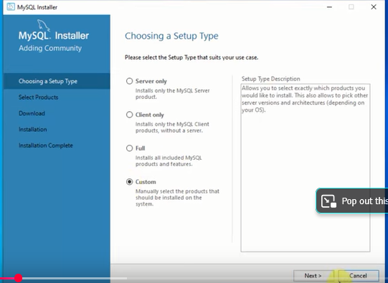
- 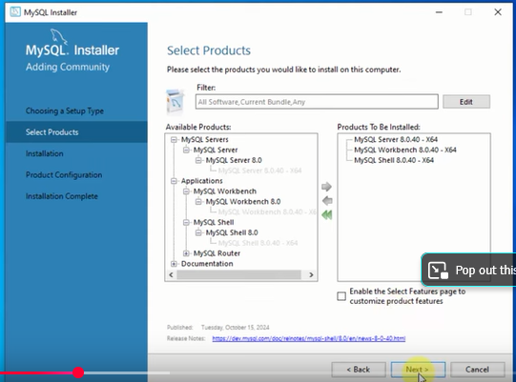
- 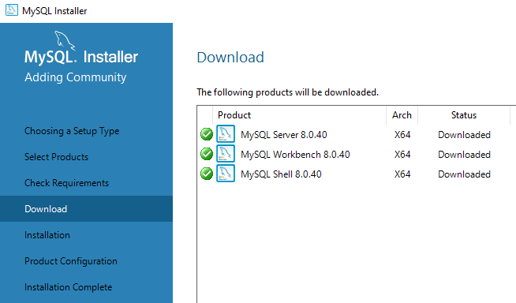

- Go with all default option by pressing NEXT
- 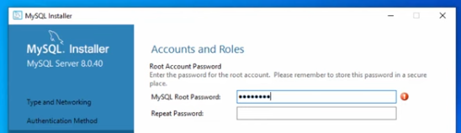
- Password : root
Remaining steps continue with default options.
Check: Open MySQL Workbench → login
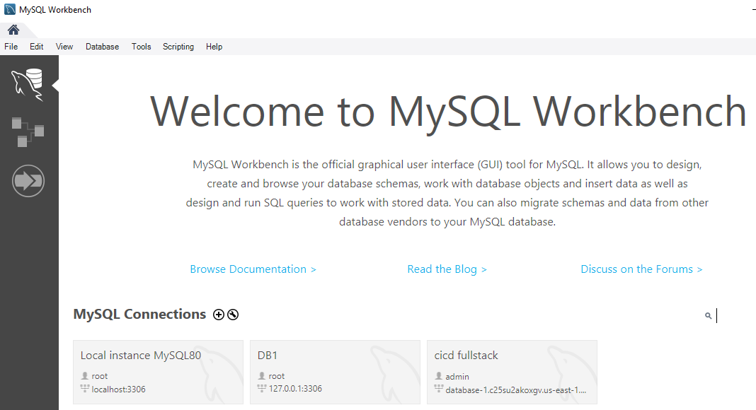

6) VS Code Installation

(You might be already installed last sem)
Steps:
- Go to → https://code.visualstudio.com
• Download Windows version
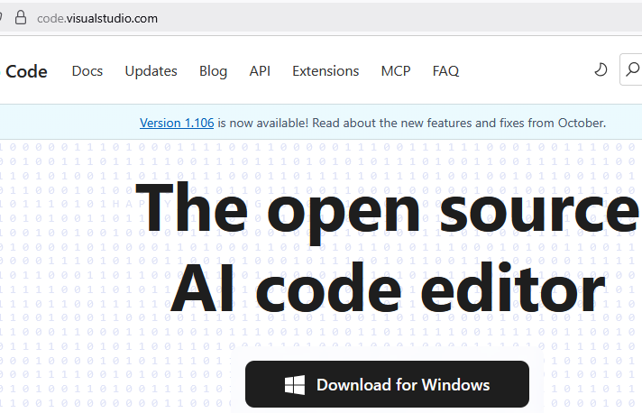
• Install with default options
• Open VS Code
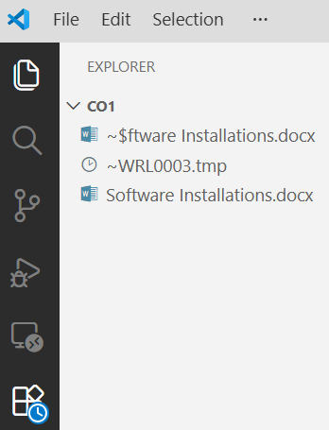
Click on the last option (3 rectangels Button to add the following extensions.)
Recommended Extensions:
- Java Extension Pack
- Spring Boot Extension Pack
- ES7+ Snippets
- Prettier

7) Node.js Installation

(You might be already installed last sem)
Steps:
- Go to → https://nodejs.org
• Download LTS version
• Install with default settings
• Check in Command Prompt: node -v
